(Approx. 760 words)

File Name Extensions - Why They Are Important
By Penny Cano, member, Cajun Clickers Computer Club, LA
November 2011 issue, Computer News
www.clickers.org
ccnewsletter (at) cox.net

From the time of DOS through Windows XP, a file extension was a “dot” followed by three characters at the end of the file's name - .JPG, .DOC, and .PDF to name a few common ones. With Vista and Windows 7, the file extension is no longer limited to three characters but is still preceded by a “dot” (.DOCX and .CONTACT for example).

Windows has an association between the extension and the program needed to open the file. If you try to open a file with the wrong program you may see something like this:

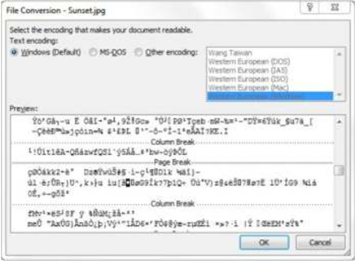

I tried to open a picture (.JPG) file with Microsoft WORD. Does this look familiar? WORD doesn't understand the contents of the picture file, so it shows what it “thinks” it should look like. Wrong! So file name extensions are pretty important! The first question I ask when someone tells me they can't open a file is, “What is the extension on the file's name?”

Maybe you've never noticed extensions before. That is no surprise because the Windows default setting is to hide them. The first step in dealing with file extensions is to be able to SEE them. From the START menu, choose Control Panel the Folder Options and on the View tab uncheck the box that says “Hide extensions for known file types.” Apply the choice, then “Apply to all Folders.” See picture on top of opposite column. The example is from Windows 7, but it is in the same place in all versions of Windows. Once you can see the extensions you can begin to learn what program is needed for each type of file.

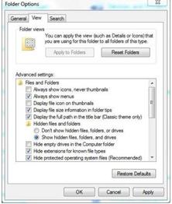

If you insert a CD, DVD, or flash drive into the computer, you will probably get something like this if AUTOPLAY is turned on:

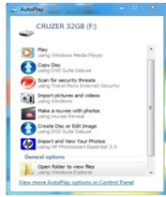

Windows is offering a list of programs it “thinks” is appropriate or at least a possibility. If you want to deal with pictures, your choice might be “Import pictures and videos” or “Import and View Your Photos.” If you have music on the device you might choose “Play.” If you just want to see what's there, you might choose “Open folder to view files.” Under each choice is the name of the program Windows will use to deal with the files. I have several types of files on this flash drive, so one program may not be appropriate for all of them. If you don't actively make the choice, Windows will choose for you and use its default (whatever is highlighted) and you may get a big surprise!

Suppose you double-click on a file and the program that comes up is not the one you want to use? Many programs you install decide to change Windows default and make themselves the “program of choice” (but maybe not YOUR choice). Or maybe you want to use a different program on a one-time basis. You can choose another program by highlighting the file (one LEFT click) then right-click on it and choose “Open with.”

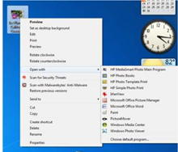

and you can choose the one you want. If you want to try different programs, use this option until you decide which one you want. This will not set the default; it is simply for the one occasion. If I were to double-click on the picture in the upper left corner, Windows would use Windows Photo Viewer to open it because that is the current (default) association between a .JPG file and a program on my computer.

If you want to change the primary (default) program for all cases, you can make the choice yourself by clicking on “Choose default program” (or “Choose program” in XP). The resulting “Open with” box has the file's name at the top.

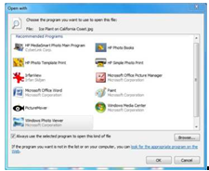

Notice the extension in .jpg in this case. Highlight the program you want to be the default, check the box that says “Always use the selected program to open this kind of file” and hit OK.

For those of you who feel brave, the “master list” of file extensions and their associated program can be found in the Control Panel. In XP it's under Folder Options on the File Types tab. In Vista and Win 7, it can be found under Default Programs and “Associate a file type with a program.”

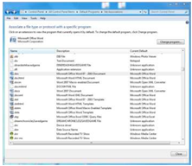

Write down the original setting BEFORE you change it and BE CAREFUL! If you set the wrong default you may get the first example above all the time.

